SYSTEM ARCHITECTURE:

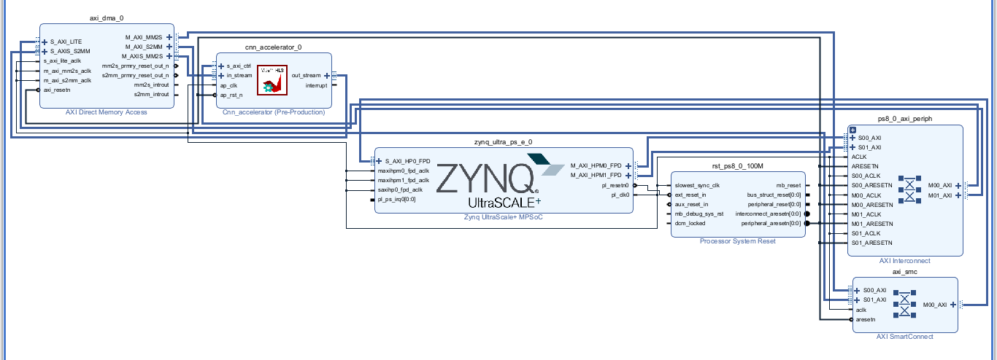

DESIGN PARTITION DECISIONS:

Hardware/Software Design Partitioning Decisions
To achieve optimal inference latency for the Convolutional Neural Network (CNN), a strict Hardware/Software (HW/SW) co-design partitioning strategy was adopted for the Zynq UltraScale+ MPSoC. The system was divided to leverage the flexibility of the ARM Cortex processor (Software/PS) for control logic, and the parallel processing power of the FPGA fabric (Hardware/PL) for mathematically intensive operations.

1. Software Partition (ARM Processor / Processing System)
The software layer is responsible for system orchestration, memory management, and establishing performance baselines. The following tasks were partitioned to the software side:
- Offline Training & Baseline Setup: The initial 3-layer CNN (Conv2D ReLU MaxPool FC) was trained offline using PyTorch, with weights and biases exported to a C-style header. A pure C++ CPU implementation was executed on the ARM core to measure the unaccelerated baseline latency T_{CPU.}
- System Control (Baremetal C Application): The ARM core handles the initialization of both the Direct Memory Access (DMA) block and the custom HLS IP.
- Data Management & Timing: The software loads the test image array into memory, starts the hardware hardware timers, and triggers the DMA transfers. It then waits for the FPGA to signal completion before reading the classification result and stopping the timer.

2. Hardware Partition (FPGA Fabric / Programmable Logic)
The computationally heavy neural network inference was entirely offloaded to the FPGA fabric to exploit spatial parallelism and dedicated hardware resources.
- CNN Accelerator IP: The convolution engine was designed in Vitis HLS C++ and exported as custom RTL IP.
- Architectural Optimizations: To guarantee maximum throughput and speedup, specific HLS pragmas were enforced. #pragma HLS PIPELINE was applied to inner loops to overlap instruction execution, while #pragma HLS UNROLL was applied to channel loops to execute parallel multiply-accumulate operations (utilizing the FPGA's physical DSP slices).
- Interface Partitioning: The IP was designed with distinct interface protocols: AXI4-Stream (axis) for high-bandwidth, continuous flow of image data input and output, and AXI4-Lite (s_axilite) for simple software control signals (Start, Done, Idle).

3. The Communication Bridge
- AXI DMA (Direct Memory Access): To prevent the ARM processor from becoming a bottleneck during data transfer, an AXI DMA block was implemented in the Vivado block design. This allows high-speed "blasting" of image data directly from DDR memory to the FPGA accelerator over the AXI4-Stream interface.

4. Evaluation Metric
This partitioning decision is validated by comparing the execution times to calculate the final system speedup using the following metric:
Speedup = T_{CPU / (}T_{FPGA} + T_{DATA_TRANSFER})

PERFORMANCE ANALYSIS:

REPORT UTILIZATION:

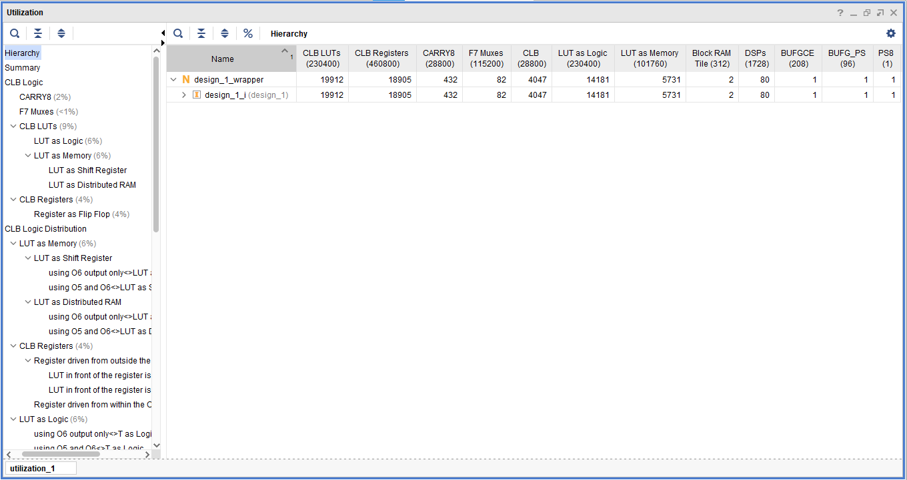

POWER UTILIZATION:

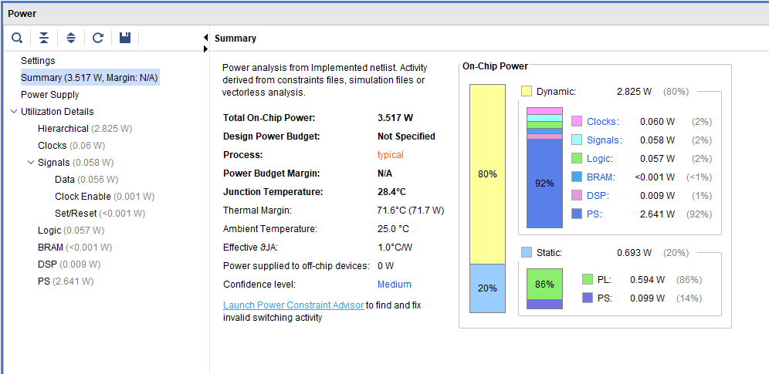

Hardware Optimization Techniques
To maximize throughput and minimize the inference latency of the Convolutional Neural Network, we applied specific hardware optimization directives (Pragmas) during the High-Level Synthesis (HLS) phase in Vitis HLS. These techniques transformed sequential C++ code into a highly parallel RTL architecture.
- Instruction-Level Parallelism (Loop Pipelining): By applying the #pragma HLS PIPELINE directive to the inner convolution loops, we optimized the initiation interval (II). Instead of waiting for one Multiply-Accumulate (MAC) operation to finish completely before starting the next, pipelining allows the hardware to process multiple overlapping operations simultaneously, drastically reducing the total clock cycles required for the convolutional layers.
- Spatial Parallelism (Loop Unrolling): We applied the #pragma HLS UNROLL directive to the channel and filter loops. This forced the HLS compiler to create multiple physical copies of the MAC hardware. By unrolling these loops, the FPGA fabric computes multiple pixel multiplications in parallel during a single clock cycle, heavily utilizing the dedicated DSP slices on the Zynq UltraScale+ board.
- Interface Optimization: The IP interfaces were optimized using #pragma HLS INTERFACE axis to implement AXI4-Stream protocols. This eliminated memory-mapped addressing bottlenecks, allowing the DMA to stream the image data directly into the accelerator as a continuous flow of pixels, further reducing the overall system latency.

FOR HARDWARE UTILIZATION WE HAVE TO USE THE SAME IMAGE AS INT EH REPORT UTILIZATION

